CALL FOR APPLICATIONS
MA IN NATIONALISM STUDIES
https://nationalism.ceu.edu/apply-now-0
Apply for a free institutional TOEFL language test by December 3!
Application deadline: January 31, 2019
Check the application requirements here.
----------------------------------------------------------------------------------------------------
Want to see behind today’s most pressing issues of nationalism?
Apply by January 31 for a scholarship and study in a US and European accredited MA program at a bi-campus university in Budapest and Vienna. Take a look at our award winning Budapest campus including the unique library, and our dormitory. Be part of our diverse student body taught by an international faculty
Founded by Ernest Gellner, CEU’s Nationalism Studies Program is one of the few programs in the world dedicated to the study of nationalism, migration, populist politics, ethnic conflict, prejudice, self-determination, populism, minority protection, and language and citizenship rights.
Fostering critical and cross-discipline approaches, our international faculty brings together a wide spectrum of expertise, such as political science, history, sociology, international relations, anthropology, social theory, social psychology and legal studies.
You will receive advanced methodological training in applied social sciences, and benefit from research opportunities, conferences and lectures, as well as field trips and study visits.
Funding
- CEU Master’s Scholarships: 100% of the tuition fee, health insurance; a monthly stipend of HUF 96,000 (approx. EUR 310) or HUF 50,000 (approx. EUR 160)
- CEU Master's Tuition Award: up to 100% of the tuition fee; health insurance for the official duration of the program
In the academic year 2018/2019, all our students received CEU funding.
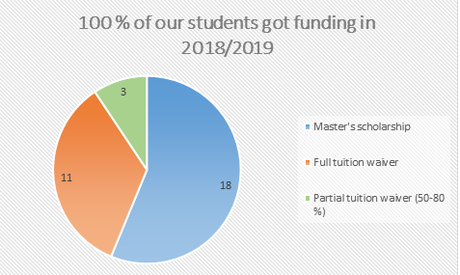
Choose your program
Our MA program comes in two formats. The one-year degree is designed for candidates with a four-year bachelor’s degree, while the two-year version is primarily for graduates with a three-year bachelor’s degree.
- MA in Nationalism Studies / 1 YEAR
- MA in Nationalism Studies / 2 YEARS
- PhD (Minor in Nationalism Studies under the auspices of the Nationalism Studies Program and the Doctoral School of Political Science, Public Policy and International Relations
What you will study
- The global challenge of migration
- Populism and right-wing politics
- The sociology and social psychology of ethnic prejudice
- Transnational citizenship and diasporas
- Nationalist politics and democracy
- Anthropological approaches to race and ethnicity
- Religious nationalism
- Self-determination and international minority protection
- Jews and Roma in comparative perspective
- Nationalism in Southeastern Europe
Check our full curriculum here.
Take a look at the theses submitted by our masters students.
Where it will take you
Alumni employment statistics
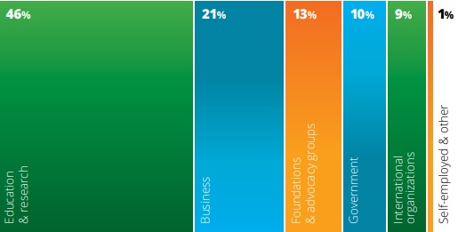
Our Faculty
- Rogers Brubaker
- Will Kymlicka
- Michael Stewart
- Christian Joppke
- Florian Bieber
- Antal Orkeny
- Daniel Bochsler
- Andras Kovacs
- Maria Kovacs
- Michael Miller
- Andras Pap
- Szabolcs Pogonyi
- Luca Varadi
Why CEU?
- Students and faculty from 115 countries
- Alumni on 6 continents in top positions
- Accredited in the U.S. and Hungary
- 8:1 student/faculty ratio
- Bi-campus university based in Budapest and Vienna, the heart of Europe
- Generous scholarships available
Meet the community
Want a sneak peek into life on campus? Check what the department and CEU have in store for students all year round. For first-hand experiences, connect with CEU students and alumni or catch up with our #MyCEU series, where students, staff and faculty tell their CEU story.
Apply by
- November 29, 2018 for the institutional TOEFL test
- January 31, 2019 for master’s and PhD studies with financial aid
- May 1, 2019 for self-financing master’s studies
Have questions?
Write to us at kissp@ceu.edu.
Our faculty and staff are happy to help you with questions related to research plans as well as the application procedure.
CEU today and tomorrow
Find out here how recent changes to Hungary’s higher education legislation may affect future CEU students. In all circumstances, you can apply to CEU with confidence and look forward to studying for a master’s or doctoral degree in a welcoming and world-class academic community!

